**Deep Learning Techniques For Breast Cancer Risk Prediction Using Python**

**1. Introduction:**

**1.1 Overview:**

Diagnosis of breast cancer is time consuming and due to the lesser availability of systems it is necessary to develop a system that can automatically diagnose breast cancer in its early stages. To increase the accuracy of prediction, deep learning algorithms such as CNN has been implemented.

**1.2 Purpose:**

The aim of this project is to evaluate the accuracy and efficiency of a deep learning approach for early breast cancer detection applied to a linked set of digital images.

**2. Literature Survey:**

**2.1 Existing Problem:**

Early diagnostics significantly increases the chances of correct treatment and survival, but this process is tedious and often leads to a disagreement between pathologists.

**2.2 Proposed Solution:**

Due to the large size of each image in the training dataset, we propose a technique which consists of two consecutive neural networks. By using deep neural networks we are predicting the cancer is benign or malignant.

**3. Theoretical Analysis:**

**3.1 Block diagram:**

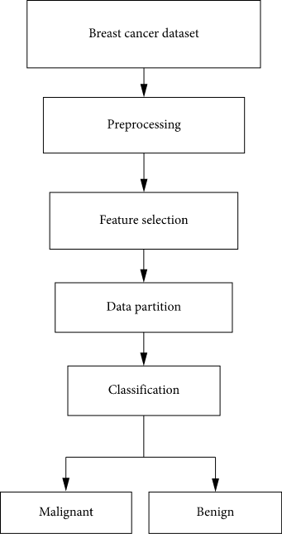

**3.2 Software Designing:**

The software part of the project would ideally involve the python. The entire project has been implemented on the laptop computer. First download the zip. Unzip it at your preferred location, get there. Now, inside the inner breast cancer classification directory, create directory datasets inside this create directory original. Download the dataset. Unzip the dataset in the original directory, we will use the tree command.

**4. Experimental investigations:**

Classification and data mining methods are an effective way to classify data. Especially in medical field, where those methods are widely used in diagnosis and analysis to make decisions. The main objective is to assess the correctness in classifying data with respect to efficiency and effectiveness of each algorithm in terms of accuracy, precision, sensitivity and specificity.

**5. Flow chart:**

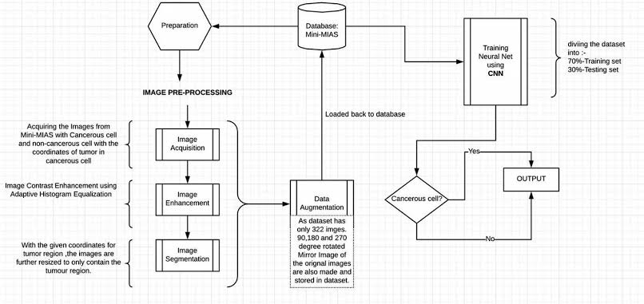

**6. Result:**

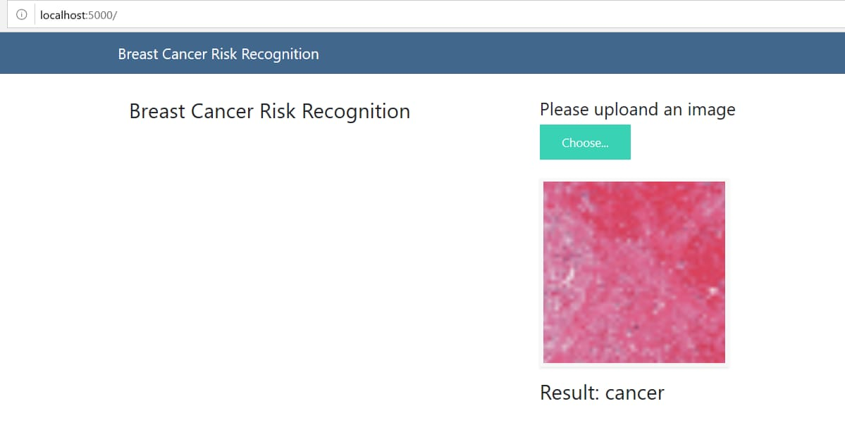

**7. Advantages & Disadvantages:**

Advantages:

1. Data input from Unlimited Resources

2. Fast Processing and Real-Time Predictions

3. Practical Scenarios

Disadvantages:

1. Data acquisition

2. Time and Resources

3. Interpretation of Results

**8. Applications:**

1. Virtual Personal Assistants

2. Predictions while Commuting

3. Videos Surveillance

4. Social Media Services

5. Email Span and Malware Filtering

6. Online Customer Support

7. Product Recommendations

**9. Conclusion:**

The deep learning approaches can be applied to assess breast cancer at a level comparable to radiologists and has the potential to substantially reduce missed diagnoses of breast cancer.

**10. Future Scope:**

The deep neural network was overall was better than density based models. The study findings support a future role for AI in breast cancer risk assessment.

**11. Bibliography:**

Ripley, Pattern Recognition and Neural Networks, 1996.

Bertsekas and Tsitsklis, Neuro-Dynamic Programming, Athena Scientific, 1996.